ANNUAL DEGREE PROGRAM ASSESSMENT REPORT

Overview
The emphasis of the report should be on PLO and CASLO assessment, action items emerging from those assessments, and a table listing the top three budget requests from each degree program. Bullet points are certainly acceptable for the sections requiring written responses. Refer to the ARPD Instructions when you upload your report elements to the system website. The roman numerals indicate the corresponding system item number for when you upload your report to the UH System website.
http://www.hawaii.edu/offices/cc/arpd/instructional.php?year=2015&action=quantitativeindicators&college=HAW
Select Maui College and your program in the drop down menus.
On the page that shows the Quantitative indicators, click on “web submission”. You will log in to get to your program submission pages.

Remember to click on “save” icon for EACH SECTION.

See the end of this document for more assistance with web submission.

2015-16 Program Review preparation guidelines
Program Name: Ag and Natural Resources
ANALYSIS TAB
I. Quantitative Indicators
CIP code is too narrow to adequately address the range of employment opportunities that are open to graduates.
STEM - Not classifying AG & Natural Resources as a STEM degree is misguided. Agriculture and Natural Resources are applied biological sciences. Students in the program receive a tremendous amount of basic knowledge of biology, chemistry, hydraulics, and ecology plus learn to apply this knowledge. There are courses in this program that are accepted as Natural Sciences electives for Liberal Arts. Yes this is a “CTE” program but it is a degree that is built on applied Science.
II. Analysis of the Program
- Any new significant program actions (new certificates, stopout, gain or loss of positions) as results of last year’s action plan.
Retirement of Faculty on Molokai. No re-hire as of this writing. Program on Molokai is in question?
Curriculum changes did not occur as still waiting for Kuali for Curriculum to open. Preliminary work in place to start inputting as soon as available. Kauli expected in Spring 2017. Mapping for STAR GPS started - some issues with the way computer program works and the every other year course offering schedule. Proposed new faculty was put forward by STEM department to full campus but did not make the cut in the campus budget.
- If relevant, share a brief analysis for any Perkins Core Indicator not met.
N/A

III. Action Plan
- Action Plan
  - PLO
This year will be implementation plan to study ATS or program certificate for CNRM as well as streamline curriculum to work with STAR GPS and help stu- dents plant for graduation.

  - Program improvement
Facilities: Greenhouse is still ripped apart from Feb 2014. O&M has sent out to bid but not fixed yet. Irrigation infrastructure on farm and greenhouse aging and need replacing. One tractor PTO is broken. Basic maintenance of field area - fringes, windbreaks, grass areas need more time spent by student help and APT. Student help budget being covered by grant funds - no funds com ing from O&M even though we have 2+ Acres of area and facilities that are part of campus that need to be maintained. Need more support and need to man age agriculture personnel better to improve facilities.
Curriculum needs to be streamlined - this is in the works for Spring 2017.
IV. Resource Implications:
The campus budget process aligns with the State of Hawaii biennium budget timeline. The next UHMC budget process will be initiated at the beginning of fall semester 2017 for the next biennium. Mid-biennium requests should address a critical need submitted through your department chair.

DESCRIPTION TAB
Provide a brief description of your program and program mission:
We envision a program that promotes active student engagement by providing high quality instruction in agriculture, horticulture, and natural resources with an emphasis on entrepreneurship and sustainability.

P-SLOs TAB
- PLO selected for assessment (click on the PLO assessed – it will turn green).
PLO: #1.
  - Industry Validation (check all that apply):

Advisory Committee Meeting(s) __, How many? _0_
Did Advisory Committee discuss CASLO/PLO? Yes__ No_x_
Coop Ed Placements _2_ Fund raising activities/events Farmers Markets - twice weekly November 2015 and once weekly April 2016. CSA - once weekly November 2015 and twice weekly April 2016. December Plant Sale - first Saturday in December. Spring Plant Sale - May 2016. Honey Sales at plant sales. Sales represent entire SUPPLY budget for this program.
Service Learning __
Provide program services that support campus and/or community
Outreach to public schools: tours with preschool and middle school students. Summer bridge High School students.
Partner with other colleges, states and/or countries __ USDA ANNH Consortium grant with 8 other UH colleges
Partner with businesses and organizations - Malama the Trees annual seminar, Maui Association of Landscape Professionals and Landscape Industry Council of Hawaii with Landscape Certification Exam on campus. Hawaii Farmers Union United and OCET - offering classes in our greenhouse and classroom and fields for public and FAM interns.
Other__ Describe_______________________________________________________________

  - Expected level of Achievement:
For the PLO assessed, _80_ % of students completing the assignment/course expected to meet expectations for the assignment/course.
  - Courses (or assignments) Assessed:
AG 230: Business Plan
AG 252: Cost of Production -100 ft of row - assigned crop.

  - Assessment strategy/Instrument/Evidence (check all that apply):
Work Sample__ Portfolio__ Project _X_ Exam __ Writing Sample __
Other_X_ Please explain__Spreadsheet__________________

  - Results of program assessment:
    - The following were present at the PLO assessment:
AG 230 Business Plan: 55% of class had a 80% or above assessment on their business plan. Another 30% received above 70%.
AG 252:66% of class completed their cost of production spreadsheet at at the 80% level.
    - Strengths and weaknesses (best practices and educational gaps) found from PLO assessment analysis .
AG 230: Have students develop a detailed outline of production prac- tices and supplies, equipment and labor activities to produce crop or service first -then begin working on business plan.
AG 252: Start semester with pre-built spreadsheet. Layout in field data collection area and assist with extrapolations of collected data to 100 ft of row spreadsheet. Have standard data collection sheets for each stu- dents assigned crops. They all did fairly well with data collection - more the extrapolation of real data to a standard area that they found confus-i ing.

  - Other comments:
Describe CASLO assessment findings and resulting action plans. Go to Laulima UHMC CASLO Assessment for your program’s “Assessment results” and summarize below.

CASLO assessment findings | Action plan to address findings
Critical thinking is clearly evident in the project. | Continue to use project but include group work to evaluate each otherʻs solutions to the problem.
Students need more explicit instructions to guide them and more hands-on experiences to better visualize solutions for their plans. | Develop more specific questions to guide students to describe 1) problem(s) they are trying to solve 2) justify why they choose the solution(s) they did  Develop several hands-on demonstration projects - build a mini system with reading a plan, put up a row of sprinklers and measure changes in throw distance etc. Do an install earlier in the semester.

  - Next steps:
For program learning outcomes (check all that apply):
Assess the next PLO___ Review PLOs___ Adjust assignment used for PLO__X_
Adjust course used for PLO___ Meet with Advisory Committee____X
Other___ Please explain:

System website:
http://www.hawaii.edu/offices/cc/arpd/instructional.php?year=2015&action=quantitativeindicators&college=HAW
Select Maui College and your program in the drop down menus.
On the page that shows the Quantitative indicators, click on “web submission”.
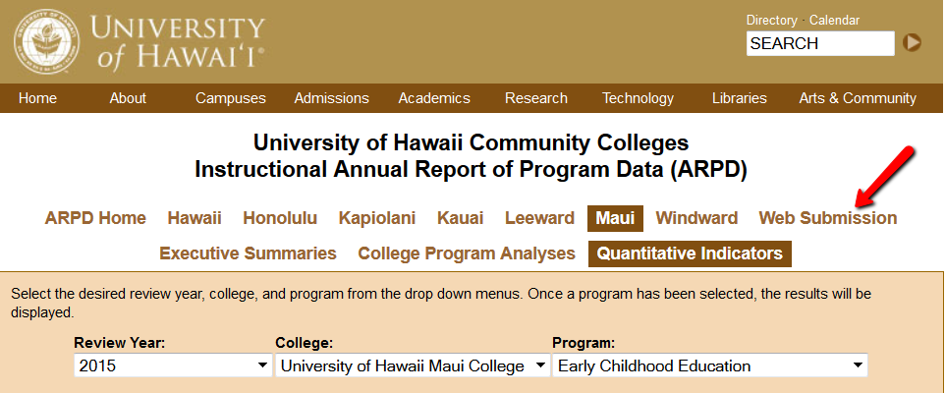

You’ll log in on the next page.
When the page with tabs comes up, click on Analysis tab.
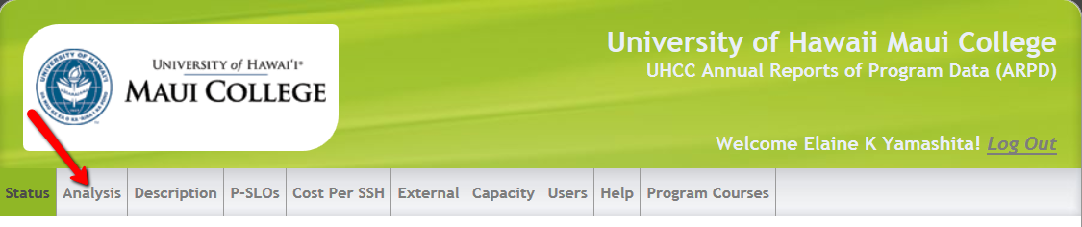

Click on “edit”. Copy and paste from this document into each section. If you are pasting from Word, you need to click on the “W” icon and then paste into the box that pops up (like in Laulima). See green arrow below.
REMEMBER TO “SAVE” EACH SECTION! (red arrow in pic below).

You’ll be entering information into:
- Analysis
- Description
- P-SLOs
- External (if your program has an external exam)

REMEMBER TO SAVE (red arrow) EACH SECTION!
